As a Client
I didn't really decide on the content, I just threw stuff down.
I emailed him and he hasn’t told me anything, so I hope it’s going well.
I would probably do a text instead of email and include the jr devs.
(no link as of yet.)
As a lead dev.
I emailed them and have had little to no response. I emailed them their parts and they have not responded with anything.
I emailed the Client and we had some problems with incomplete information, so my jr devs had not a whole lot to do.
I have not figured that out yet and am waiting to get the complete website according to the wireframe to figure it out.
I didn’t like it.
https://github.com/IronRift/wdd130/tree/main/final_project
As a Jr dev.
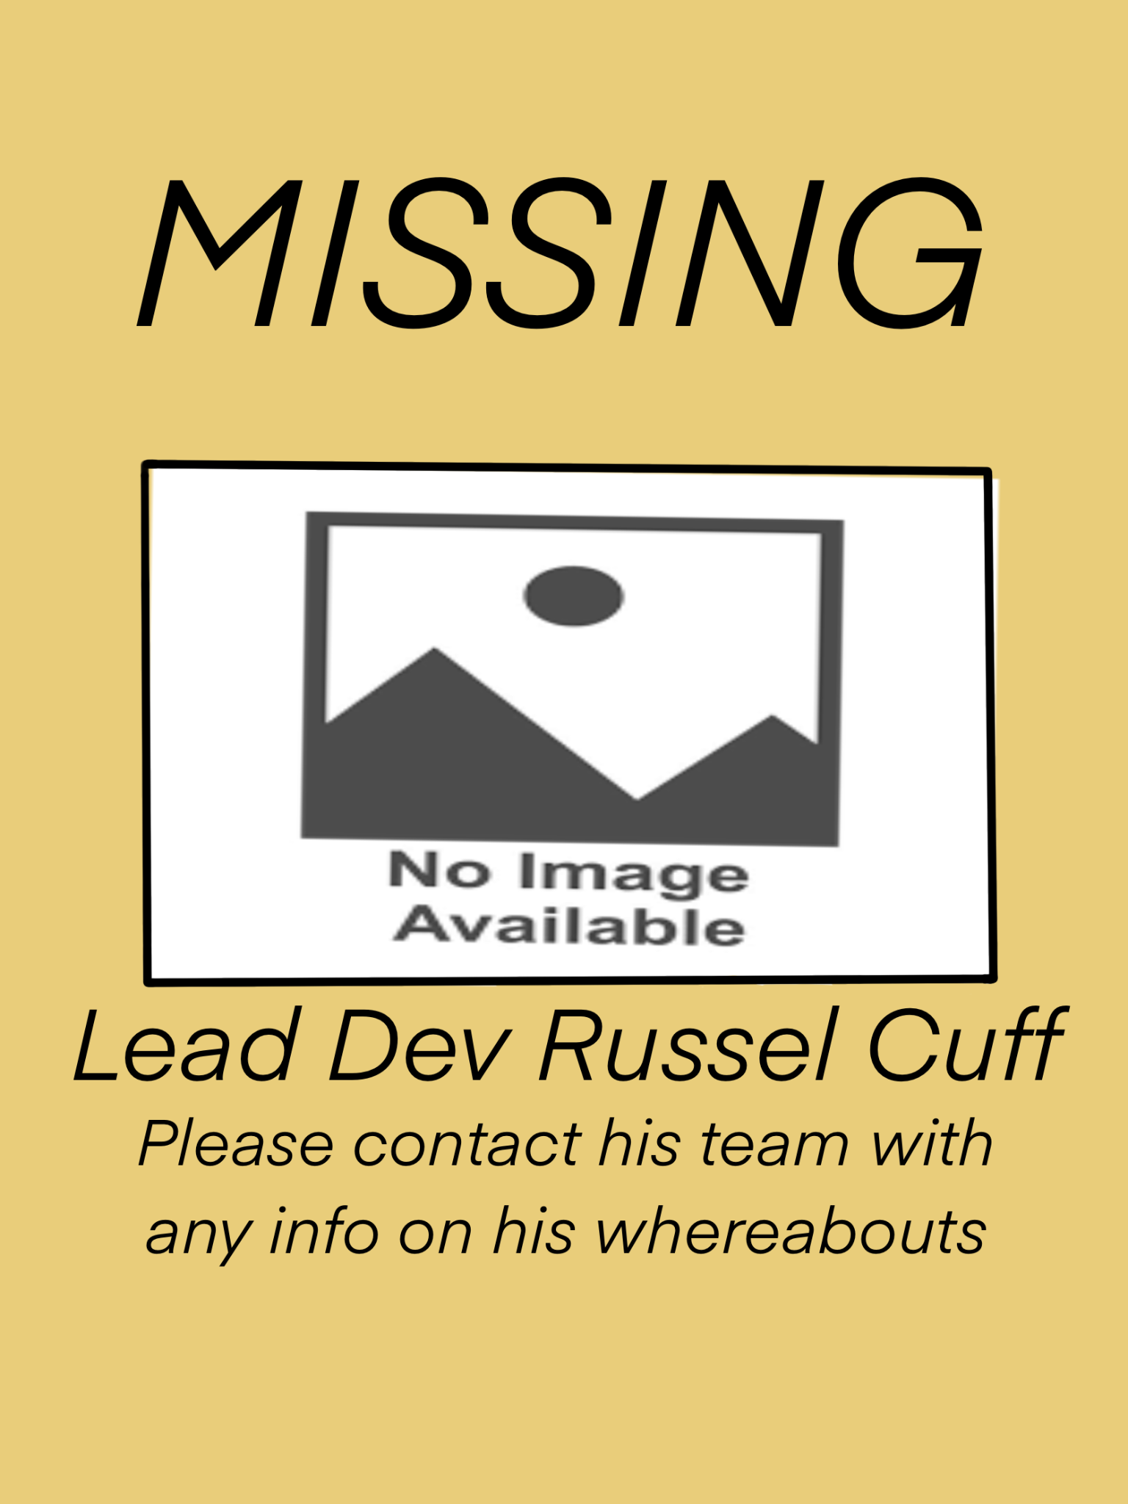
Communication. I had a little from one group and none from the other. Here is what I did instead.

No.
A little to one, but none for the other.
I had no trouble.
https://github.com/josh-catala/Project-Pulse
General
Communication was rough. I had little or no response from people. I did not overcome it.
Making crap up to put on the incomplete sites
Probably use text instead of email.
No, because I didn’t do a whole lot. I did what I could, but it wasn’t challenging.

